**Electronics Gadget – Task 1**



**CREATE DATABASE TechShop;**

**USE TechShop;**



**CREATE TABLE Customers (**

**CustomerID INT AUTO_INCREMENT PRIMARY KEY,**

**FirstName VARCHAR(50) NOT NULL,**

**LastName VARCHAR(50) NOT NULL,**

**Email VARCHAR(100) UNIQUE NOT NULL,**

**Phone VARCHAR(15),**

**Address TEXT**

**);**

**CREATE TABLE Products (**

**ProductID INT AUTO_INCREMENT PRIMARY KEY,**

**ProductName VARCHAR(100) NOT NULL,**

**Description TEXT,**

**Price DECIMAL(10,2) NOT NULL,**

**StockQuantity INT NOT NULL**

**);**

**CREATE TABLE Orders (**

**OrderID INT AUTO_INCREMENT PRIMARY KEY,**

**CustomerID INT,**

**OrderDate TIMESTAMP DEFAULT CURRENT_TIMESTAMP,**

**TotalAmount DECIMAL(10,2),**

**FOREIGN KEY (CustomerID) REFERENCES Customers(CustomerID) ON DELETE CASCADE**

**);**

**CREATE TABLE OrderDetails (**

**OrderDetailID INT AUTO_INCREMENT PRIMARY KEY,**

**OrderID INT,**

**ProductID INT,**

**Quantity INT NOT NULL,**

**SubTotal DECIMAL(10,2),**

**FOREIGN KEY (OrderID) REFERENCES Orders(OrderID) ON DELETE CASCADE,**

**FOREIGN KEY (ProductID) REFERENCES Products(ProductID) ON DELETE CASCADE**

**);**

**CREATE TABLE Inventory (**

**InventoryID INT AUTO_INCREMENT PRIMARY KEY,**

**ProductID INT,**

**QuantityInStock INT NOT NULL,**

**LastUpdated TIMESTAMP DEFAULT CURRENT_TIMESTAMP ON UPDATE CURRENT_TIMESTAMP,**

**FOREIGN KEY (ProductID) REFERENCES Products(ProductID) ON DELETE CASCADE**

**);**



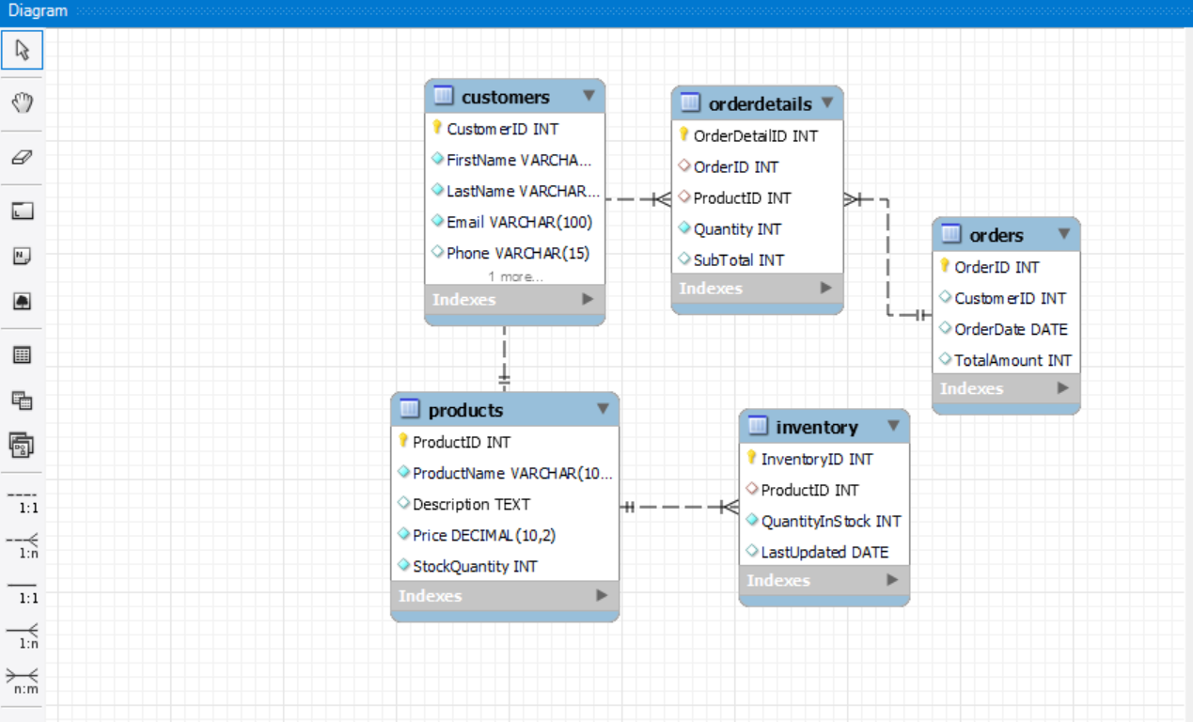

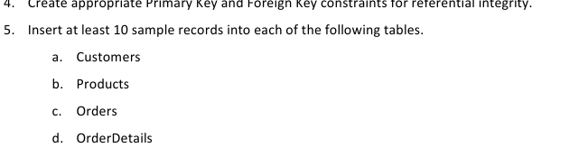

**-- Customers**

**INSERT INTO Customers (FirstName, LastName, Email, Phone, Address) VALUES**

**('John', 'Doe', 'john.doe@example.com', '1234567890', '123 Main St'),**

**('Jane', 'Smith', 'jane.smith@example.com', '9876543210', '456 Oak St'),**

**('Alice', 'Brown', 'alice.b@example.com', '1112223333', '789 Pine St'),**

**('Bob', 'Johnson', 'bob.j@example.com', '4445556666', '101 Elm St'),**

**('Charlie', 'Lee', 'charlie.lee@example.com', '7778889999', '202 Birch St'),**

**('David', 'White', 'david.white@example.com', '5556667777', '303 Cedar St'),**

**('Emma', 'Wilson', 'emma.w@example.com', '6667778888', '404 Maple St'),**

**('Frank', 'Moore', 'frank.m@example.com', '9990001111', '505 Walnut St'),**

**('Grace', 'Taylor', 'grace.t@example.com', '2223334444', '606 Spruce St'),**

**('Henry', 'Adams', 'henry.a@example.com', '3334445555', '707 Redwood St');**

**-- Products**

**INSERT INTO Products (ProductName, Description, Price, StockQuantity) VALUES**

**('Laptop', 'High performance laptop', 1200.00, 20),**

**('Smartphone', 'Latest model smartphone', 800.00, 50),**

**('Headphones', 'Noise-cancelling headphones', 150.00, 100),**

**('Keyboard', 'Mechanical keyboard', 80.00, 75),**

**('Mouse', 'Wireless mouse', 40.00, 60),**

**('Monitor', '4K Ultra HD monitor', 300.00, 30),**

**('Printer', 'All-in-one printer', 200.00, 25),**

**('Tablet', 'Android tablet', 500.00, 35),**

**('Speakers', 'Bluetooth speakers', 120.00, 45),**

**('External HDD', '1TB external hard drive', 90.00, 40);**

**-- Orders**

**INSERT INTO Orders (CustomerID, TotalAmount) VALUES**

**(1, 1500.00),**

**(2, 900.00),**

**(3, 1300.00),**

**(4, 450.00),**

**(5, 700.00),**

**(6, 1250.00),**

**(7, 300.00),**

**(8, 500.00),**

**(9, 800.00),**

**(10, 1100.00);**

**-- OrderDetails**

**INSERT INTO OrderDetails (OrderID, ProductID, Quantity, SubTotal) VALUES**

**(1, 1, 1, 1200.00),**

**(1, 2, 1, 800.00),**

**(2, 3, 2, 300.00),**

**(2, 4, 1, 80.00),**

**(3, 5, 2, 80.00),**

**(3, 6, 1, 300.00),**

**(4, 7, 1, 200.00),**

**(5, 8, 1, 500.00),**

**(6, 9, 1, 120.00),**

**(7, 10, 2, 180.00);**

**-- Inventory**

**INSERT INTO Inventory (ProductID, QuantityInStock) VALUES**

**(1, 20),**

**(2, 50),**

**(3, 100),**

**(4, 75),**

**(5, 60),**

**(6, 30),**

**(7, 25),**

**(8, 35),**

**(9, 45),**

**(10, 40);**